I READ THE TEXT AND THEN ANSWER THE QUESTIONS BELOW

What is 3D Printing?
3D printing or additive manufacturing is a process of making three dimensional solid objects from a digital file.
The creation of a 3D printed object is achieved using additive processes. In an additive process an object is created by laying down successive layers of material until the object is created. Each of these layers can be seen as a thinly sliced horizontal cross-section of the eventual object.
3D printing is the opposite of subtractive manufacturing which is cutting out / hollowing out a piece of metal or plastic with for instance a milling machine.
3D printing enables you to produce complex shapes using less material than traditional manufacturing methods.

How Does 3D Printing Work?
It all starts with a 3D model. You create one yourself or download it from a 3D repository. When creating it yourself you can choose to use a 3D scanner, app, haptic device, code or 3D modeling software.

3D Modeling Software
There are many different 3D modeling software tools available. Industrial grade software can easily cost thousands a year per license, but there’s also open source software you can get for free.
We often recommend beginners to start with Tinkercad. Tinkercad is free and works in your browser, you don’t have to install it on your computer. Tinkercad offers beginner lessons and has a built-in feature to get your 3D model printed via a 3D print service.
Now that you have a 3D model, the next step is to prepare the file for your 3D printer. This is called slicing.

Slicing: From 3D Model to 3D Printer
Slicing is dividing a 3D model into hundreds or thousands of horizontal layers and is done with slicing software.
Some 3D printers have a built-in slicer and let you feed the raw .stl, .obj or even CAD file.
When your file is sliced, it’s ready to be fed to your 3D printer. This can be done via USB, SD or internet. Your sliced 3D model is now ready to be 3D printed layer by layer.

3D Printing Industry
Adoption of 3D printing has reached critical mass as those who have yet to integrate additive manufacturing somewhere in their supply chain are now part of an ever-shrinking minority. Where 3D printing was only suitable for prototyping and one-off manufacturing in the early stages, it is now rapidly transforming into a production technology.
Most of the current demand for 3D printing is industrial in nature. As it evolves, 3D printing technology is destined to transform almost every major industry and change the way we live, work, and play in the future.

Examples of 3D Printing
3D printing encompasses many forms of technologies and materials as 3D printing is being used in almost all industries you could think of. It’s important to see it as a cluster of diverse industries with a myriad of different applications.
A few examples:
- – consumer products (eyewear, footwear, design, furniture)
- – industrial products (manufacturing tools, prototypes, functional end-use parts)
- – dental products
- – prosthetics
- – architectural scale models & maquettes
- – reconstructing fossils
- – replicating ancient artefacts
- – reconstructing evidence in forensic pathology
- – movie props
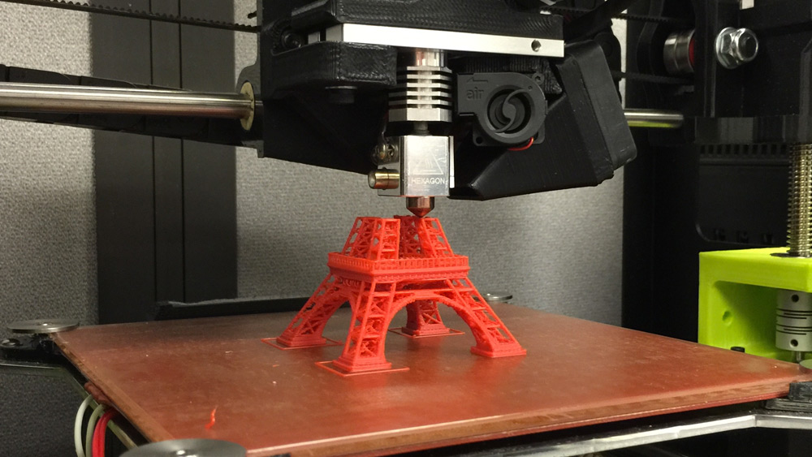
Questions about the text: try to provide as detailed responses as possible
- How would you define 3D printing?
- Is the process in 3D printing the same as the one found in subtractive manufacturing?
- What kind of machine is a milling machine?What is it used for?
- What is the advantage of 3D printing over traditional manufacturing methods?
- What are some of the tools that can help you make your own 3D models?
- What is the most suitable software for 3D modelling if you are a beginner and why?
- What is slicing?
- Is 3D printing technology nowadays used only for making prototypes?
- How would you paraphrase ’’a myriad of different applications’’?
- Find one example of 3D printing on the internet and try to describe it by writing one paragraph on it in English.

Guess the word behind the definition
1.’’a thin sheet of a substance on top of a surface, or a level of material that is different from the material on either side’’ ___________________
2.’’a part of something cut from the rest of it, usually cut from side to side, in order to see its inside structure, or a drawing of this’’ ________________
3.’’a device that rotates a circular tool that has a number of cutting edges symmetrically arranged about its axis; the workpiece is commonly held in a vise or similar device clamped to a table that can move in three perpendicular directions’’_______________________

Try to give your own definitions for the words listed below
built-in feature-
via-
repository-
hollow out-
feed to the printer-
Translate these terms into Serbian
supply chain-
current demand-
cluster-

